**Documents: Data in this laptop, kept in Computer/Documents(E:)**

**Process 1: Drawing the SR-1501:**

Base of the diagram:

Assumptions:

* Assumed outside rectangle fillet radius 2.5
* Assumed tangency of the circles in the sides of the motor

Measured:

* Radius of the circle for the screw on the top of motor:2.34mm
* Distance of the circle for the screw to the center: 7.05mm
* Radius of the big circle on the top:20mm
* Thickness of the upwards circle: 2.06mm
* Side shape top length: 11.78mm
* Side shape middle length: 16.74mm
* Height of the bottom part of the spinny thing:3.6mm
* Height of the bottom part: 4.9mm
* Distance between the outside tangent part of circle to circle:1.84mm
* Radius of the bottom part of the upwards circle: 8.08mm
* Bottom shape length: 9.5mm
* Distance between the top of the upwards circle and the bottom: 6.3mm
* Width of the whole part:3.24mm
* Distance to the ends: 2.95
* Thickness of Holder: 2.2mm
* Connecting holes with Holder:4.32mm diameter

Wrong Assumptions:

* Assumed tangency of the circles in the sides of the motor, not tangent.

Holder motor hole to ends distance: 9.01mm

Actual motor hole to ends distance: 10mm

Height of motor assembly final:

51.5mm+ axis(1mm) = 52.5mm

Holder documentation:

Radius of circles: 2.76

Distance between them: 7.08

Connecting hole with Motor SR-1501: 3.8 diameter

Wrong

Holder dimensions are exactly the same as that of motor hole

Holder center to the end dimension: 42.4mm

Holder bottom holes: Radius 2.34 and distance between each other 9. Vertical with origin and distance from top is 23.

Pelvis:

* Length of motor hole: Original length+1+2*2+6 = 52. 5+4+1+6= 63 .6

Solidworks Feet specifications:

* Shell thickness: 2mm
* Length: 15mm
* Width: 5-7mm
* Shoe: Height of the highest is 6-7mm, max at the ends and min in the middle Max height distance is 4 and 3 respectively
* Shin Basic Documentation:
* Width of shin: Motor length + shell*2 = 52.5+2*2 = 56.5mm
* Width of shin should actually be motor length* shell*2 = 51.5+1+2*2 = 56.5
* Height of shin: 150mm
* Length of shin: 100mm
* Dimension of the shell thing: Multi-variable. 3mm for bottom and 1.7mm for everywhere else.

Shoe:

* Current dimensions only allow 33.7 space
* I want 39.24 space

Thigh Dimensions:

Height: 200mm

Length: 60mm

Width of shin: 51.5+2*2 = 55.5

Shell thickness: 2mm everywhere and 3mm at the bottom.

Additional space given for motor to turn: 39.24

Total amount of exact space needed: 38.24

Solidworks notes:

Properties:

- Rotate Entities: When you have two distinct distance dimensions between two points, that somehow rely on factors such as horizontal and vertical projections and shit. Thus, if you may need to rotate make sure you change these distances. This may include swapping them around, if the rotational angle is 90 degrees

Putting a point in the intersection of a line and a spline:

* Coincide the point with the line first, and then with the spline afterwards. Do this separately

Putting a point in the intersection of a line and a circle:

* Select all three sketch entities, and choose “make intersection”.

Chest Documentation:

1. Dimensions provided 30*17mm. My dimensions 54.5*20mm. Thus, need to make my thing a lot taller

2. Actual height of motor: 51.5mm

3. Their given space: 47mm - 2*2.7mm = 47mm - 5.4mm = 41.6mm. Thus, it needs to be 5.48mm wider. That halved is 2.74mm

Screw documentation:

Screw diameter measured major axis(including the thread): 2.94mm

Screw diameter minor axis: 2.34mm

Screw top(bolt part) width: 5mm

Screw length: 8.64mm

Screw head length; 2.04mm

Bottom of head of screw – End of screw fastener: 8.64-2.04 = 6.6mm

Amount of revolutions of the screw thread(螺纹数量): 12

Pitch of the screw thread(螺距):6.6mm/12 =0.55mm

Height of screw thread: 0.3mm

Length of my triangle for sweep cut: 0.52mm(basic trig)

Thread basics:

Major axis: 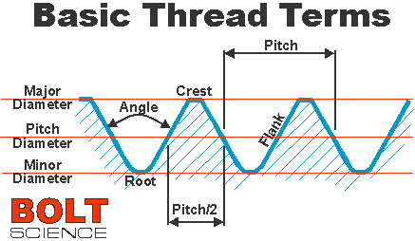

Lead: Distance of screw threads along the axis that is covered by one complete rotation of the screw （周期）

Pitch: Distance between the crest of a thread to the next(螺距)

Typical screws are triangular, in the sense that the crest and the minor, the thread-form resembles a triangle, typically a isocellles one. This is called the “V- thread”

Male and female defines the direction in which the crest is facing(external-male) and (internal-female)

The M, denotes the largest diameter of the screw, the diameter of the major axis. Thus, M3 means 3 millimeters on the major axis

The second measurement denotes the pitch length, say 1.5mm.

The final measurement denotes the distance between the bottom of the head of the screw to the end of the fastener of the screw. This is, for instance, 30mm.

Very Useful image:

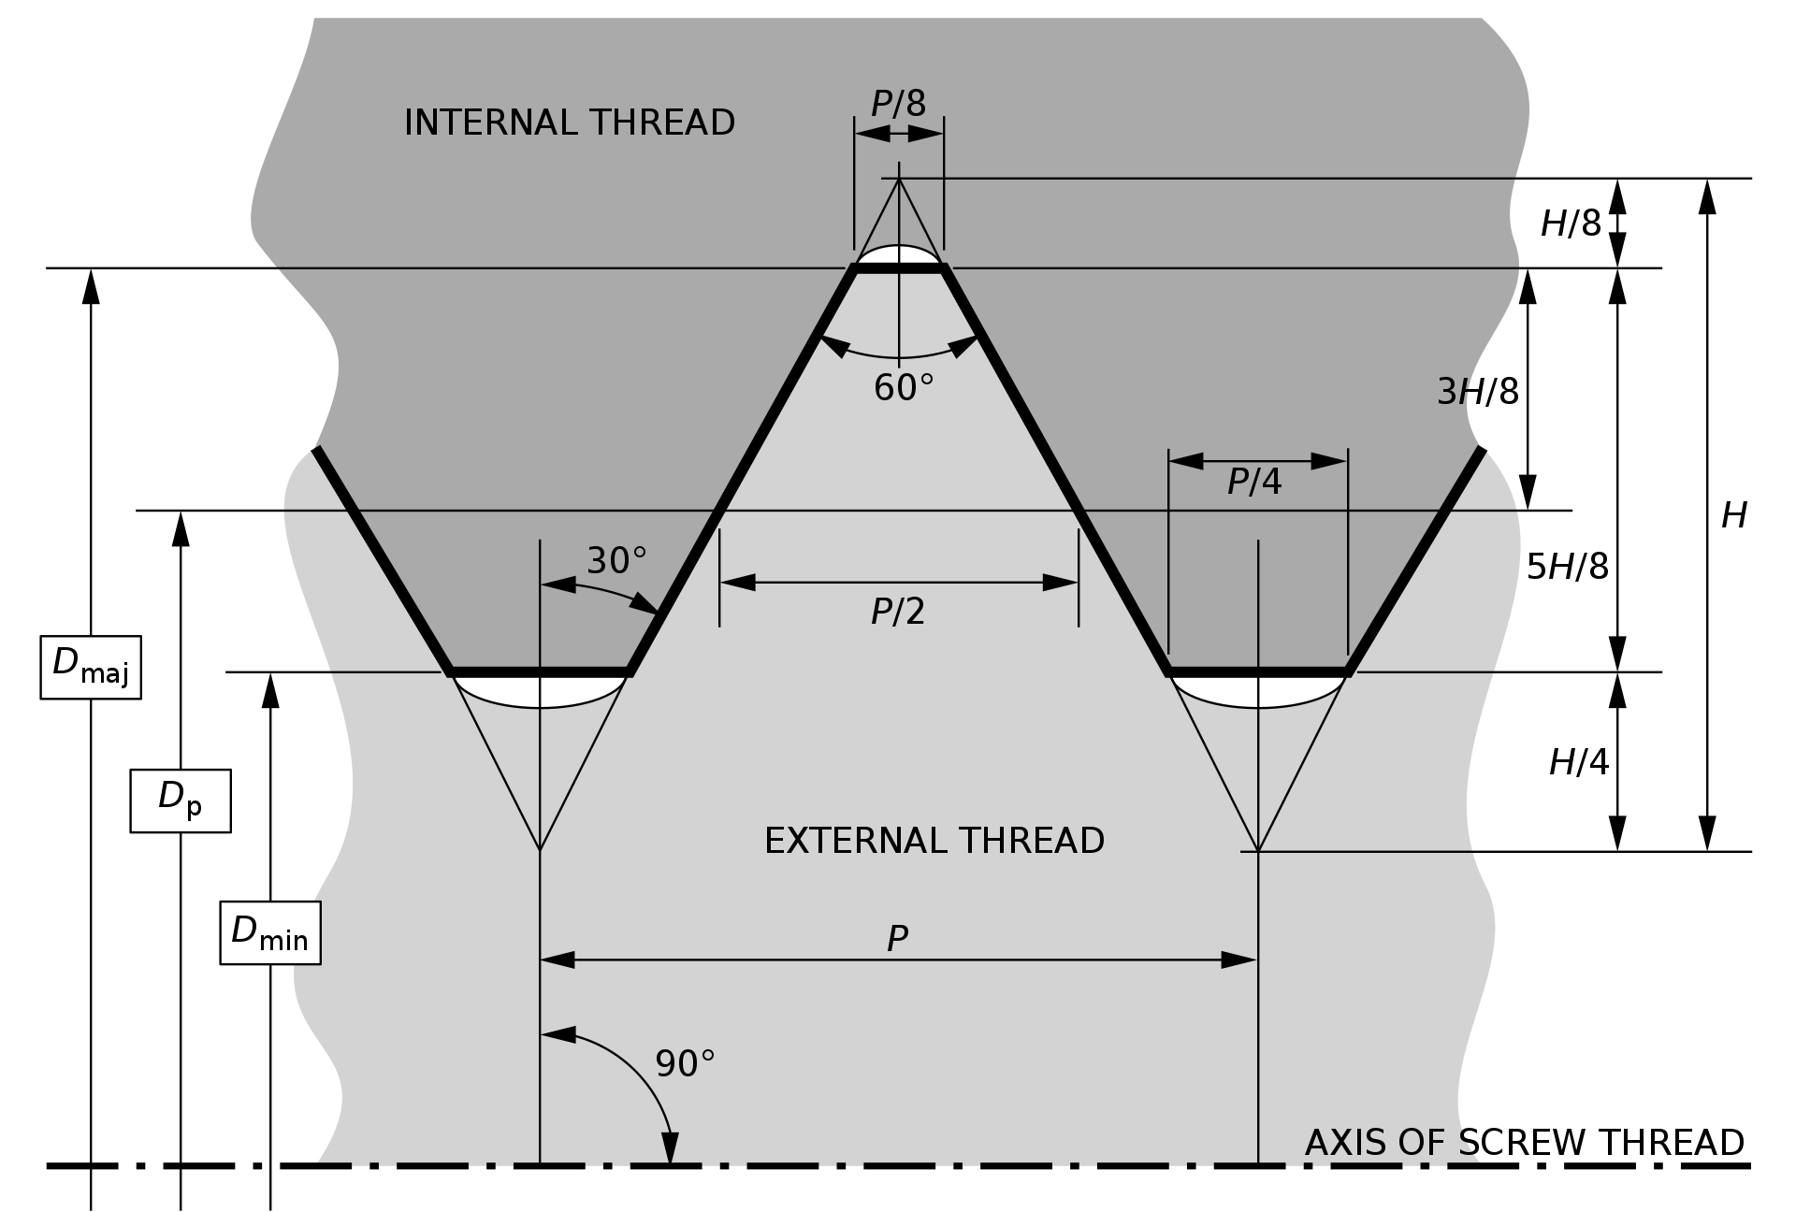

D – Denotes distance of major, pitch and minor diameter

P – pitch

H- height of screw

Types of screws that are necessary:

M3 screws and M4 screws

Solidworks problems:

* Cannot successfully rotate entities in sketch whilst keeping relations(no matter what)
* Cannot rotate a goddamn plane, say, 90 degrees around it’s origin
* Cannot delete coincident endpoints of two collinear lines.

Solidworks skills:

Special things:

Sketch flange:

<https://www.youtube.com/watch?v=35gBHZ77z0I>

Used to lift up the edge part of a sheet metal up vertically. Very cool.

Connector piece: Sheet metal turning radius: 1mm

Edge flange length: 20mm

View perspective will have the dimensions done wrong. Thus we need to disable the view of perspective.

Hip motor dimensions:

* It is primarily made of an intersection body
* Shortest width: 57.5mm
* Longest width required: 66.9mm\

Part 1(Hip connector): stats:

- Added an extrude from the outside of the part